



Essay / Assignment Title: AI-Driven Image Recognition for Automated Plant Disease Diagnosis in Modern Smart Farming
Programme title: Computer Vision and Artificial Intelligence
Name: Naga Surendera Babu Aravapalli
Year: 2026

CONTENTS

Table of Contents
CONTENTS 2
Table of Contents 2
List of Tables: - 4
List of Figures: - 4
1. INTRODUCTION 6
1.1 Abstract: - 6
1.2 Introduction: - 6
1.3 Methodology: - [10] 7
2. Literature Review 8
2.1 Literature review: - 8
3. Data preparation 10
3.1 Data Description: - 10
3.2 Key Characteristics: - 10
3.3 Various preprocessing stages are as follows: 10
4. Model Architecture 12
4.1 Conceptual Architectural Diagram: 13
4.2 Parameter analysis: 13
4.3 Expandable Comparison: 13
4.4 Architectures to compare: 13
4.5 Advantages and Limitations: 13
5. Implementation 15
6. Model Evaluation 17
6.1 Accuracy and Loss curves: - 17
6.2 Accuracy: - 19
6.3 Confusion Matrix Analysis: - 20
6.4 ROC Curve: - 21
7. CONCLUDING REMARKS 22
7.1 Findings: - 22
7.2 Recommendations 23
8. BIBLIOGRAPHY (References) 24
9. APPENDIX (Dataset link and Python code link) 25

List of Tables: -
Table 1 Images categorized 11
Table 2 Layer types 12
Table 3 Sequential Model 16
Table 4 Epochs - 30 applied 16

List of Figures: -
Figure 1 Tomato methodology flow chart as example 7
Figure 2 Accuracy and Validation accuracy curve-1 17
Figure 3 Accuracy and Validation accuracy curve-2 30 Epochs 18
Figure 4 Accuracy and Validation accuracy curve-3 19
Figure 5 Confusion Matrix (Heat Map) 20
Figure 6 ROC - AUC Curve 21

Statement of compliance with academic ethics and the avoidance of plagiarism

I honestly declare that this dissertation is entirely my own work and none of its part has been copied from printed or electronic sources, translated from foreign sources and reproduced from essays of other researchers or students. Wherever I have been based on ideas or other people texts I clearly declare it through the good use of references following academic ethics.
(In the case that is proved that part of the essay does not constitute an original work, but a copy of an already published essay or from another source, the student will be expelled permanently from the program).

Name and Surname (Capital letters): NAGA SURENDERA BABU ARAVAPALLI
Date: 06/02/2026

1. INTRODUCTION

1.1 Abstract: -
Identification of crop diseases can protect the crops, which can increase agricultural production, control harvest losses, and maintain global food security. Agri chemicals and pesticides cause environmental pollution and threaten the farmers' health as well, so Modern methods are better than Traditional applications to fasten the inspections by farmers or agricultural specialists, especially for large-scale farm setups. Deep learning techniques [1] will detect the plant disease using an AI-based image classification system. The Plant Disease Dataset, PlantVillage, was used from Kaggle. A convolutional neural network (CNN) model was used with TensorFlow and Keras to implement MobileNetV2. The evaluation of the framework applied various performance metrics, including Precision, accuracy, recall, F1-Score and confusion matrix. It has gained high classification accuracy and robust inference performance. The research indicates that deep learning-based image classification is an effective and adaptable solution for automated plant disease detection in contemporary smart agriculture.

1.2 Introduction: -
Agriculture plays an important role in global food security, and plant diseases affect the crops. In earlier stages, fungal, bacterial, and viral infections spread rapidly. The farmers rely on visual inspection and the expert's knowledge to identify the plant disease. However, it was very difficult for large-scale-farming. Therefore, in the modern world, recent advancements in computer vision and artificial intelligence (AI) developed to detect the early plant diseases automatically. Convolutional Neural Networks (CNNs) in deep learning gives a best performance for image classification tasks that builds automatic discriminative features from raw pixel data. The main object of this study is to design and improve deep leaning based image classification to detect multiple diseases automatically from leaf images. The aim of this study to show how AI can support farmers and agricultural experts in effective and efficient decision makings. The framework extreme to help ranchers and rural specialists by advertising a fast, exact, and reasonable decision-support instrument for diagnosing illnesses. This consider appears how profound learning can be viably utilized to address an honest to goodness rural issue.

1.3 Methodology: - [10]
This methodology consists of important points from deep learning standard code of practice, aiming to build an efficient leaf disease detection system. The image preprocessing pipeline can apply data augmentation techniques. Below image was considered for the Tomato leaf disease images as an example. Potato, Grap, Apple, Cherry, Corn, Peach, Pepper and Strawberry all these variety of plant leaf follow the same flow like Tomato.
The architecture is useful to balance accuracy and computational efficiency that matches to agricultural applications.
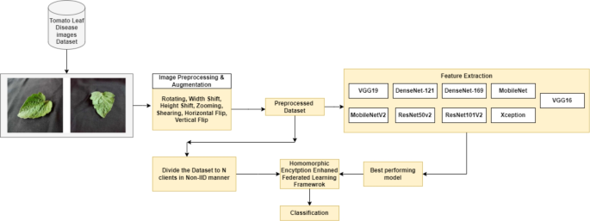
Figure 1 Tomato methodology flow chart as example

2. Literature Review

2.1 Literature review: -
This literature [4] is carried out on detecting and classifying plant or crop disease. Beginning ponders on identifying plant maladies concentrated on ordinary picture handling strategies. Procedures like color histogram investigation, edge location, surface extraction, and shape descriptors were as often as possible utilized. As profound learning has progressed, strategies based on CNNs have gotten to be predominant in recognizing plant infections. Exchange learning has appeared to be especially invaluable, given that pre-trained models have profitable include representations obtained from broad datasets such as ImageNet. Later thinks about have highlighted lightweight models like MobileNet and EfficientNet, advertising competitive exactness whereas utilizing less parameters and decreasing computational costs. This is often pivotal for viable usage on portable phones and edge gadgets. This extend grows on earlier inquire about by utilizing a lightweight CNN demonstrate based on exchange learning and evaluating its viability for real-world rural employments. Applied image_size (224), Zooming, epochs range-30, test & train accuracy, colours (RGB), batch size – 20.
2.2 Problem Formulation: -
Plant maladies proliferate rapidly and are difficult to track physically over broad farmland. The most issue handled in this venture is the nonattendance of a robotized, versatile, and exact framework for early recognizable proof of plant illnesses. The objective is to make a multi-class picture classification challenge in which input pictures of plant takes off are categorized into suitable infection sorts. Many ranchers require access to expert knowledge, leading to delayed or incorrect disease diagnoses. The matter addressed in this context is the enhancement of an automated system that can accurately categorize plant leaf images into specified disease classifications. Officially, when presented with an image of a plant leaf, the system should predict the correct disease progression or identify the leaf as healthy. The classification displayed should be accurate, robust, and computationally efficient.
2.3 Objectives of the extend: -
- Make a profound learning demonstrate for classifying plant infections.
- Utilize labeled picture information to prepare the demonstrate.
- Evaluate demonstrate adequacy by utilizing standard measurements.
- Look at limitations and recommend improvements.

3. Data preparation

3.1 Data Description: -
The dataset of PlantVillage was captured from the Kaggle website (https://www.kaggle.com/datasets/mgmitesh/plant-disease-detection-dataset) for analysis. It is to research plant diseases and control their impact. The class labels across multiple crops available for supervised deep learning techniques [6] in the long run. It has over 50,000 images of various crop species, including tomato, potato, corn, apple, grape, and pepper.

3.2 Key Characteristics: -
- Total Images: Over 50,000
- Image format: JPEG
- Colour Channels: RGB (Red, Green, Blue)
- Classes: healthy leaves along with various disease categories

3.3 Various preprocessing stages are as follows:
- The pixels of all images are 224 x 224, which is connected with the different dimensions of the EfficientNetV2 [5] input.
- The image classification task is challenging due to the nature of multi-classed diseases.
- Image pixels were ranged from [0, 255] to [0, 10] by dividing by 255.
- Normalizing the training numbers to improve stability and convergence.
- Real-time data augmentation procedure applied to raise dataset diversity and control overfitting. Different operations were used, including random rotations, Horizontal and Vertical flipping, zooming, and Width/height adjustments.
- Dataset categorized into three subsets as
Training set: 70% - Used for Model training.
Validation set: 20% - To tune the hyperparameter and
Test set: 10% - To evaluate the final performance levels.
Finally, the CNN model is uploaded into the pipeline to load images into batches and use augmentation to train the data. This kind of automated pipeline aims to improve reproducibility and to handle data efficiently.
Images categorised as appearing in the screenshot.
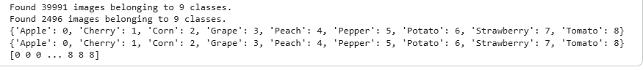
Table 1 Images categorized

4. Model Architecture

A Convolutional Neural Network (CNN) architecture [9] is a specialized neural network structured to process data grid like images and videos. It is known as data hierarchical structure and highly effective to perform the task like image recognition, object detection, and classification.
It applies filters (Kernels) to input data. Overfitting reduced to 0.5 rate as layer result. Softmax to control overfitting. Layer Details are as below.
Layer Type | Input Size / Shape | Parameters | Purpose / Description
Input Layer | 224 × 224 × 3 (RGB) | — | Accepts colour leaf images and preserves spatial and colour information.
Convolutional Layer 1 | 224 × 224 × 3 | 32 filters, 3 × 3 kernel, ReLU | Extracts low-level features such as edges, corners, and textures.
MaxPooling2D Layer 1 | 2 × 2 pool size | — | Reduces spatial dimensions and computational complexity.
Convolutional Layer 2 | Feature maps | 64 filters, 3 × 3 kernel, ReLU | Learns mid-level patterns such as spots and shapes.
MaxPooling2D Layer 2 | 2 × 2 pool size | — | Further down-sampling and feature compression.
Convolutional Layer 3 | Feature maps | 128 filters, 3 × 3 kernel, ReLU | Captures high-level disease-related structures.
MaxPooling2D Layer 3 | 2 × 2 pool size | — | Controls overfitting and reduces feature size.
Flatten Layer | — | — | Converts 2D feature maps into 1D feature vector.
Fully Connected (Dense) | 128 neurons | ReLU activation | Learns global relationships among extracted features.
Dropout Layer | Rate = 0.5 | — | Prevents overfitting by randomly disabling neurons.
Output Layer | Number of classes | Softmax activation | Produces class probabilities for final classification.
Table 2 Layer types

4.1 Conceptual Architectural Diagram:
Here, this Architecture diagram is conceptually suitable.
Input → Conv (32) → MaxPool → Conv (64) → MaxPool → Conv (128) → MaxPool → Flatten → Dense (128) → Dropout → Softmax

4.2 Parameter analysis:
As the filter count grows, every convolutional block raises the number of trainable parameters. This model has lightweight comparing to others. Approximate parameter distributions,
Conv Block 1: ~900 parameters
Conv Block 2: ~18,000 parameters
Conv Block 3: ~74,000 parameters
Dense Layers: Majority of parameters

4.3 Expandable Comparison:
- Various ways to extend the architecture
- More filters for high accuracy
- Increasing additional convolutional blocks
- Global Average Pooling replaces the dense layers
- Overall Calculations in cost and storage depends on required flexibility in depth or width.

4.4 Architectures to compare:
CNN required minimum computations for better performance.
ResNet: Deep networks followed by residual connections
MobileNet: Lower wight and fit for mobile deployment

4.5 Advantages and Limitations:
Advantages:
Automatic transfer learning [7] techniques of discriminative features without manual intervention.
Easy to extend more layers or filters.
Training the model with more efficiency.
Limitations:
Sometimes not possible to reach state-of-the-art accuracy
Limited availability of residual or attention procedures which has computational expensive.
Difficult to apply for large-scale farming.

5. Implementation

The Python system was implemented with the following libraries:
- TensorFlow / Keras
- NumPy
- Matplotlib
- Scikit-learn
To Load Data:
Keras ImageDataGenerator was loaded with images that apply to real-time augmentation as well.

Assemble the Models:
Loss function: Categorical Cross-Entropy
Neutralizer: Adam
Metrics: Accuracy

Training:
The trained model has multiple batches, with each batch containing 32. It was monitored for training and validation accuracy and loss.

Evolution on test data:
The test data and performance metrics were evaluated for the models trained.
The accompanying Jupyter Notebook (Agriculture_Images.ipynb) demonstrates the full implementation pipeline, including model training and evaluation.

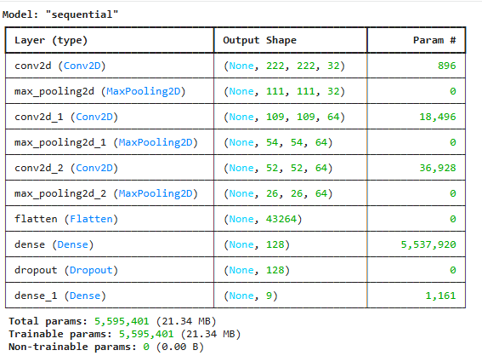
Table 3 Sequential Model
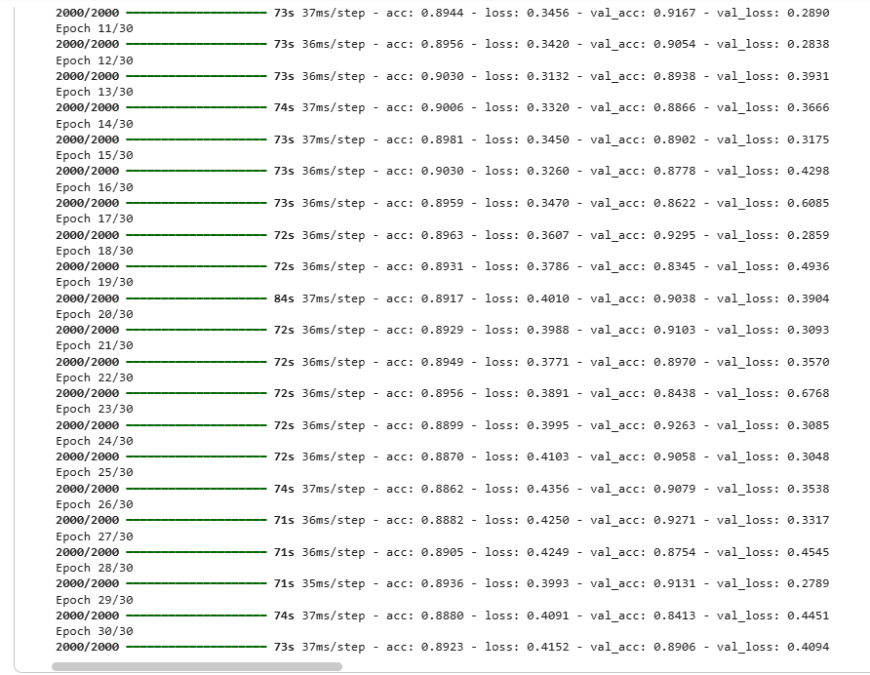
Table 4 Epochs - 30 applied

6. Model Evaluation

Model performance was evaluated with multiple metrics. The model has achieved high training and validation accuracy, indicating an effective understanding of the specific disease features.
Accuracy: It measures overall classification correctness.
Precision and Recall: To evaluate class-wise prediction quality
F1-score: To balance precision and recall
Confusion Matrix: Visualises misclassifications over the different classes

6.1 Accuracy and Loss curves: -
Initially, both training and validation accuracy curves increased rapidly, with convergence around 88–92%.
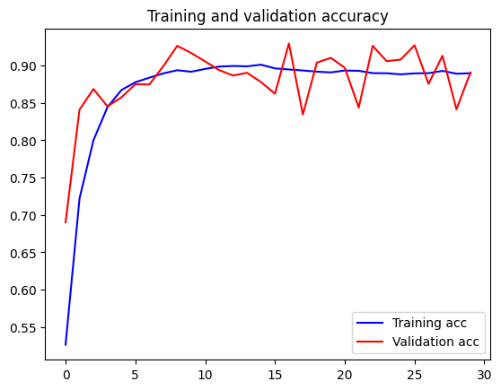
Figure 2 Accuracy and Validation accuracy curve-1
Observations:
- Minimum overfitting due to a small gap between training and validation accuracy.
- The performance of 10 epochs suggests that further training earns additional improvements.

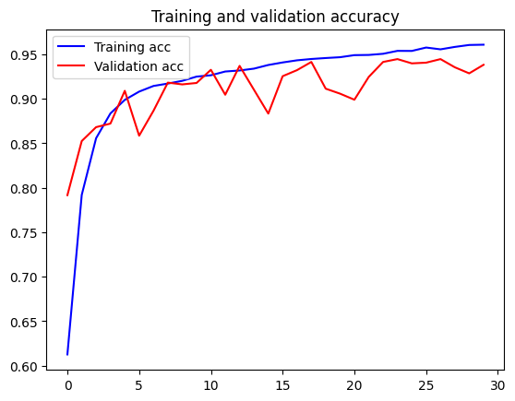
Figure 3 Accuracy and Validation accuracy curve-2 30 Epochs
Observations:
- After reaching 8 - 10 epochs, both curves start by demonstrating stable convergence, training accuracy stabilised around 95 – 96%, whereas validation accuracy fluctuated between 92 - 95%.
- Finally, This model ends with balanced bias–variance trade–off, and the performance of unseen data is classified as strong.

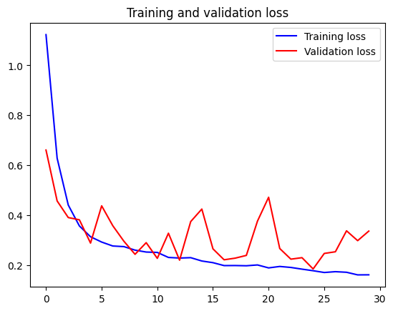
Figure 4 Accuracy and Validation accuracy curve-3

Observations:
- Training accuracy increased continuously until it reached to ~0.95 - 0.96 at the 30th epoch in later stages. Mild overfitting over there.
- Validation accuracy consists noise due to instability after 5 - 8 epochs.

6.2 Accuracy: -
test Accuracy: 89.06%
train Accuracy: 96.68%

6.3 Confusion Matrix Analysis: -
The Tree map shows how much better a classification model predicts various fruit/vegetable classes. The confusion matrix views true versus predicted class labels.
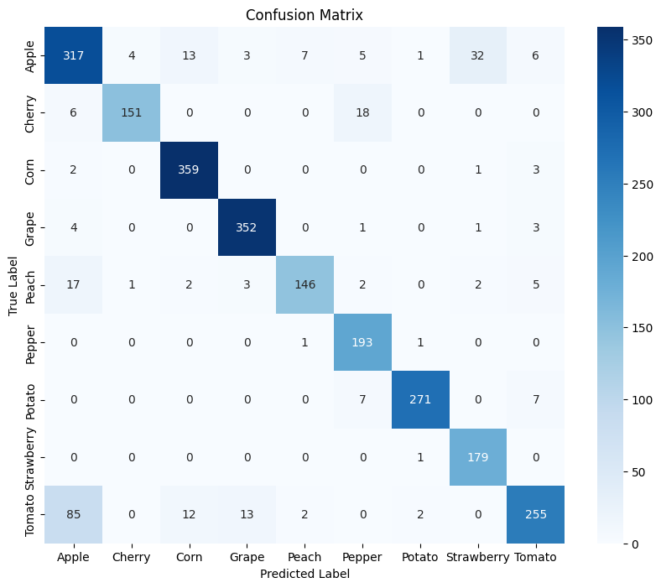
Figure 5 Confusion Matrix (Heat Map)
Observation: -
- The overall accuracy of Corn and Grape is classified as best (Corn = 359, Grape = 352, Potato = 271). Hence, it gives the right predictions without any confusion.
- Apple and Tomato confusion due to errors, whereas no misclassifications in Cherry (151 correct) and Strawberry (179), recognising the model as most reliable.

6.4 ROC Curve: -
F1 Score: 0.8892
Precision: 0.8962
Recall: 0.8906
ROC-AUC Score: 0.9913
ROC – AUC Curve: -
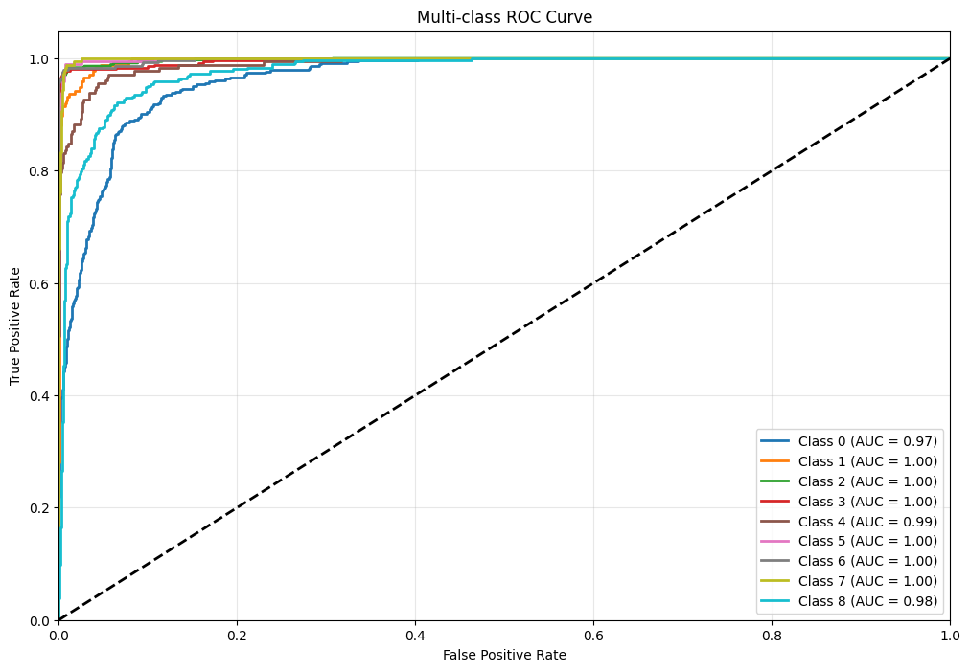
Figure 6 ROC - AUC Curve
Observations:
- All AUC values are between ~0.97 and 1.00, so the model distinguishes classes with high performance.
- ROC curves stay above the diagonal baseline, which indicates the model performs better than the prediction line.

7. CONCLUDING REMARKS

This project demonstrates the successful application of deep learning for automated plant disease diagnosis. By leveraging CNNs and transfer learning, the system achieves strong classification performance while remaining computationally efficient. Although limitations such as dataset bias and real-world variability remain, the proposed approach shows significant potential for deployment in smart farming environments.
Future work may include expanding the dataset, improving robustness under field conditions, and integrating the model into mobile or IoT-based agricultural platforms.

7.1 Findings: -
The implementation and evaluation of deep learning-based image classification models for plant disease diagnosis led to some important findings:
- The Analytical results from plant leaf disease classification confirm that Convolutional Neural Networks are very effective. Strong classification accuracy was achieved with both custom CNN and MobileNetV2 transfer learning models. Deep learning will automatically extract visual features such as different colours, texture patterns, and lesion shapes from leaf images.
- The MobileNetV2 model gives more convergent and best generalization comparing to the custom CNN. Large-scale image datasets allow the model to make consistency for rich, low-level and mid-level visual features. These datasets need to give weightages based on pre-trained status.
- Visualization analysis helps to the data augmentation to control overfitting together training and validation accuracy. It uses different techniques like image rotation, flipping, and zooming. It exposes the network into various visual patterns.
- The confusion matrix says that the model has extreme performance among different disease classes whenever classifications not match between diseases with similarity. According to the image-based approaches it identifies the plant disease recognition and limitations.
- Visualization of Training curves, confusion matrices and prediction results are more understandable and accountability. These visualization tools make to get learning approach, bottleneck patterns and other areas of optimization.

7.2 Recommendations
Based on the above study, the following recommendations are proposed:
- It is required build more discriminative or advanced feature (textures, color histograms, deep CNN features) extractions to minimize the confusion among similar categories.
- Training data needs high generalization will collect or augment many trails for recent misclassified classes (Like Apple or Tomato).
- Data augmentation techniques like rotation, scaling and lighting variation have to apply to robust the model.
- Use to class-specific thresholds to adjust or fine-tune the model architecture. It is important to decrease the false positives while improving the true positive rates.
- Increase in advanced architectures (ResNet, EfficientNet, or Vision Transformers (ViTs)) to enhance the classification accuracy particularly for likewise disease classes.

8. BIBLIOGRAPHY (References)

1. Tufail, M., Iqbal, J., Tiwana, M.I., Alam, M.S., Khan, Z.A. and Khan, M.T. (2021) ‘Identification of tobacco crop based on machine learning for a precision agricultural sprayer’, IEEE Access, 9, pp. 23814–23825.
2. Moupojou, E., et al. (2023) ‘FieldPlant: A dataset of field plant images for plant disease detection and classification with deep learning’, IEEE Access, 11, pp. 35398–35410.
3. Balafas, V., Karantoumanis, E., Louta, M. and Ploskas, N. (2023) ‘Machine learning and deep learning for plant disease classification and detection’, IEEE Access, 11, pp. 114352–114377.
4. Shafik, W., Tufail, A., Namoun, A., De Silva, L.C. and Apong, R.A.A.H.M. (2023) ‘A systematic literature review on plant disease detection: Motivations, classification techniques, datasets, challenges, and future trends’, IEEE Access, 11, pp. 59174–59203.
5. S.C.K., J.C.D. and Patil, N. (2022) ‘Cardamom plant disease detection approach using EfficientNetV2’, IEEE Access, 10, pp. 789–804.
6. Madhurya, C. and Jubilson, E.A. (2024) ‘YR2S: Efficient deep learning technique for detecting and classifying plant leaf diseases’, IEEE Access, 12, pp. 3790–3804.
7. Patnayakuni, S.P. (2022) ‘Tomato: Different leaf disease detection using transfer learning-based network’, Journal of Mobile Multimedia, 18(3), pp. 743–756
8. Rashid, R., Aslam, W., Aziz, R. & Aldehim, G., 2024. An early and smart detection of corn plant leaf diseases using IoT and deep learning multi-models. IEEE Access, 12, pp.23149–23162.
9. Shrotriya, A., Kumar Sharma, A., Kumar Bairwa, A. & Manoj, R., 2024. Hybrid ensemble learning with CNN and RNN for multimodal cotton plant disease detection. IEEE Access, 12, pp.198028–198045.
10. Muntaqim, M.Z., Kafi, H.M. and Smrity, T.A., 2026. Privacy-aware plant disease detection: federated learning with homomorphic encryption on image data. The Visual Computer, 42(1), p.18.

9. APPENDIX (Dataset link and Python code link)

Source link for Dataset: - https://www.kaggle.com/datasets/mgmitesh/plant-disease-detection-dataset
Python Code Link: - https://drive.google.com/file/d/1iCoxPJt8TSj83RVQfl2mVnDx0IGdtI1j/view?usp=sharing

